|  |  |  |  |  |
| --- | --- | --- | --- | --- |
|  |  | | |  |
|  | | |
|  | | |
| 方圆ok1 | | | |
|  | **Huawei Data Communication Network Basics**  Lab Construction Guide | |  |
| **For Version 1.0** | |
|  |  |
|  |  |
|  | |
| HUAWEI TECHNOLOGIES CO., LTD. | |
|  | | |

|  |
| --- |
| Copyright © Huawei Technologies Co., Ltd. 2020. All rights reserved.  No part of this document may be reproduced or transmitted in any form or by any means without prior written consent of Huawei Technologies Co., Ltd.  Trademarks and Permissions  and other Huawei trademarks are trademarks of Huawei Technologies Co., Ltd.  All other trademarks and trade names mentioned in this document are the property of their respective holders. |

|  |  |
| --- | --- |
| Huawei Technologies Co., Ltd.  Training & Certification Dept. | |
| Address: | Huawei Industrial Base  Bantian, Longgang  Shenzhen 518129  People's Republic of China |
| Website: | <http://learning.huawei.com> |
| Email: | [learning@huawei.com](mailto:learning@huawei.com) |
|  |  |

**Revision History**

| For Version | Date | Description |
| --- | --- | --- |
| 1.0 | 2020.3 | New version |

**Guide Information**

| Author | Time Range | Reader |
| --- | --- | --- |
| Talent Ecosystem Development Dept | 2020.3-… | Regional Offices, Suppliers, & Huawei Authorized Learning Partners (HALP). |

Contents

1 About this Document 1

2 The Datacom Lab Topology 1

3 Equipment Purchasing 2

4 Cable Connection 2

5 Problems Caused by Non-standard Equipment 5

6 Precautions 5

7 Appendices 5

# About this Document

After the experiment has been standard, the experimental equipment was determined. In consideration of demand for the upgrading of teaching materials, generating a list of experimental equipment and physical connection topology.

This guide provides supporting information for HAINA, regional offices, suppliers, and Huawei Authorized Learning Partners (HALP) for the purchase of equipment, installation of modules, cables, and configuration of related equipment required for construction of the Huawei Data Communication Network Basics lab environment, and aid in supporting the corresponding lab training, as part of the Huawei Data Communication Network Basics course.

# The Datacom Lab Topology

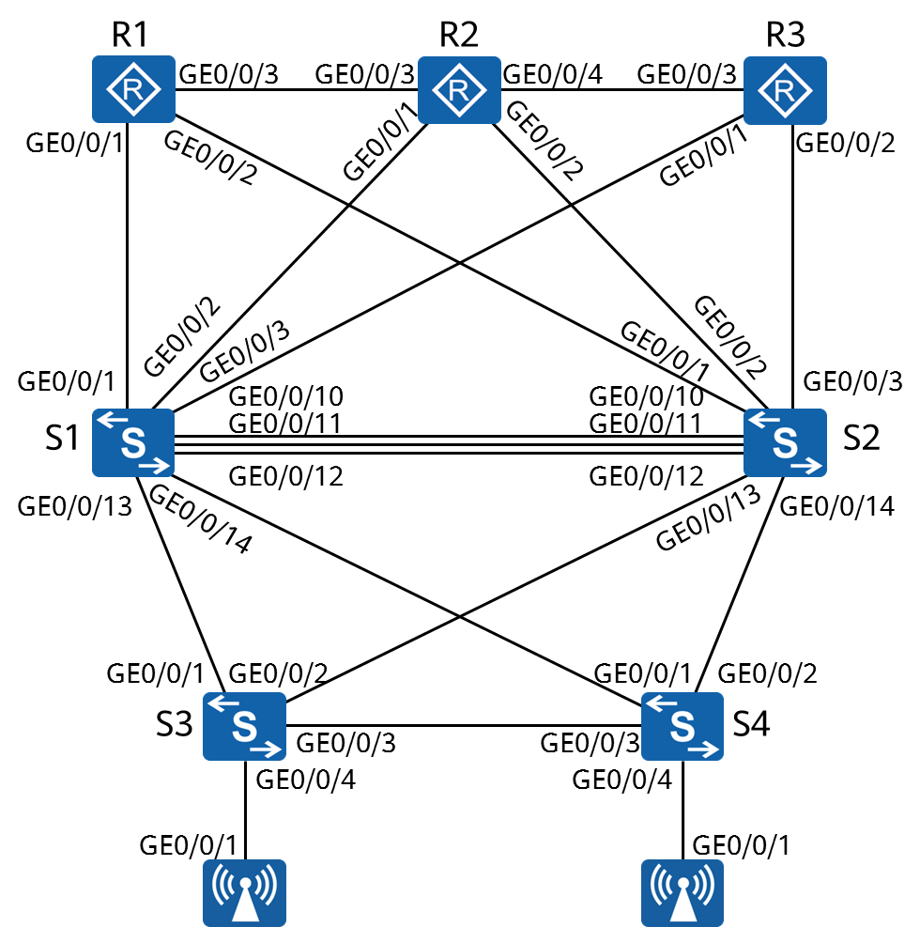

note**Figure 2-1** Datacom Physical Topology

The physical topology shown in Figure 2-1 contains all equipment on the purchase list.

# Equipment Purchasing

You must purchase the equipment based on the lab requirements. If you have any doubt, send email to [learning@huawei.com](mailto:learning@huawei.com). The equipment purchase list, named Huawei Data Communication Network Basics Experiment Equipment List for V1.0 is attached as part of Appendices.

# Cable Connection

The equipment must be connected based on the topology shown in Figure 2-1.

Ensure that the correct models are used for the different types of equipment based on the mapping provided in Table 4-1.

**Table 4-1 Required model for different types of equipment**

|  |  |
| --- | --- |
| Equipment | Model |
| R1 | AR 651C |
| R2 | AR 651C |
| R3 | AR 651C |
| S1 | S5731-H24T4XC |
| S2 | S5731-H24T4XC |
| S3 | S5731-H24P4XC |
| S4 | S5731-H24P4XC |
| AP1 | AirEngine5760-10 |
| AP2 | AirEngine5760-10 |

Check whether the ports are connected correctly based on Table 4-2.

**Table 4-2 Required mapping between ports**

|  |  |  |
| --- | --- | --- |
| **R1** | GE0/0/1 | S1 |
| GE0/0/2 | S2 |
| GE0/0/3 | R1 |
| **R2** | GE0/0/1 | S1 |
| GE0/0/2 | S2 |
| GE0/0/3 | R1 |
| GE0/0/4 | R2 |
| **R3** | GE0/0/1 | S1 |
| GE0/0/2 | S2 |
| GE0/0/3 | R2 |
| **S1** | GE0/0/1 | R1 |
| GE0/0/2 | R2 |
| GE0/0/3 | R3 |
| GE0/0/10 | S2 |
| GE0/0/11 | S2 |
| GE0/0/12 | S2 |
| GE0/0/13 | S3 |
| GE0/0/14 | S4 |
| **S2** | GE0/0/1 | R1 |
| GE0/0/2 | R2 |
| GE0/0/3 | R3 |
| GE0/0/10 | S1 |
| GE0/0/11 | S1 |
| GE0/0/12 | S1 |
| GE0/0/13 | S3 |
| GE0/0/13 | S4 |
| **S3** | GE0/0/1 | S1 |
| GE0/0/2 | S2 |
| GE0/0/3 | S3 |
| GE0/0/4 | AP1 |
| **S4** | GE0/0/1 | S1 |
| GE0/0/2 | S2 |
| GE0/0/3 | S3 |
| GE0/0/4 | AP2 |
| **AP1** | GE0/0/1 | S3 |
| **AP2** | GE0/0/2 | S4 |

# Problems Caused by Non-standard Equipment

You must use the standard equipment contained on the equipment list in 7 Appendices when building the lab.

The non-standard equipment may cause problems, including but not limited to the following items:

1. The commands may be found to be incompatible, or the interface names are not consistent with the ones in the lab guide.
2. Parts of the lab results cannot be displayed.
3. The non-standard equipment is not compatible with the lab guide or learning materials of later versions.

# Precautions

After the instructor conducts training of the learning materials, the students are expected to independently carry out and complete the steps listed in the Lab Guide. If any fault occurs, the students should ask for troubleshooting support from the instructor.

For all the AR651C routers, interface GE0/0/0~GE0/0/7 are switch port by default, instructor should configure them to be layer three port by using command ’undo portswitch’ and save as default configuration.

In the experiment, in order to avoid the influence of residual configuration on the experiment, after the completion of the experiment, students should delete the equipment configuration information before closing the equipment; at the same time, at the beginning of the experiment, confirm the equipment from the empty configuration, or perform configuration empty, and restart the equipment.

# Appendices

